Hi everyone,
I am excited about our next virtual PHA support group meeting and hope to see everyone there! Please do not click the meeting link more than 10 minutes before the meeting. If you would like a practice link to test out the Ring Central Meetings app on your device before the meeting, please let me know and I will reach out to PHA for a practice link.
Meeting Details
Date:
Time:
Topic:
Speaker:
Online link and telephone number (do not click the link more than 10 minutes before the meeting):

Instructions to Join via Computer
When you click on the link, a web page will open and this pop-up box will appear. Click “Open RingCentral Meetings”. Enable pop-ups on your web browser. If the pop-up box doesn’t appear, click “download & run RingCentral Meetings” at the bottom of the screen.
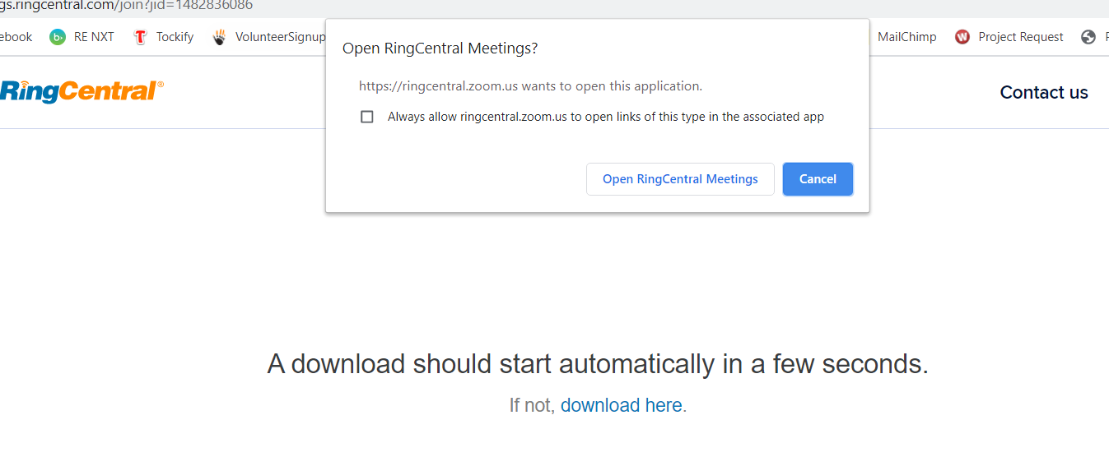
Next, this audio option box will appear. Click “Join with Computer Audio”.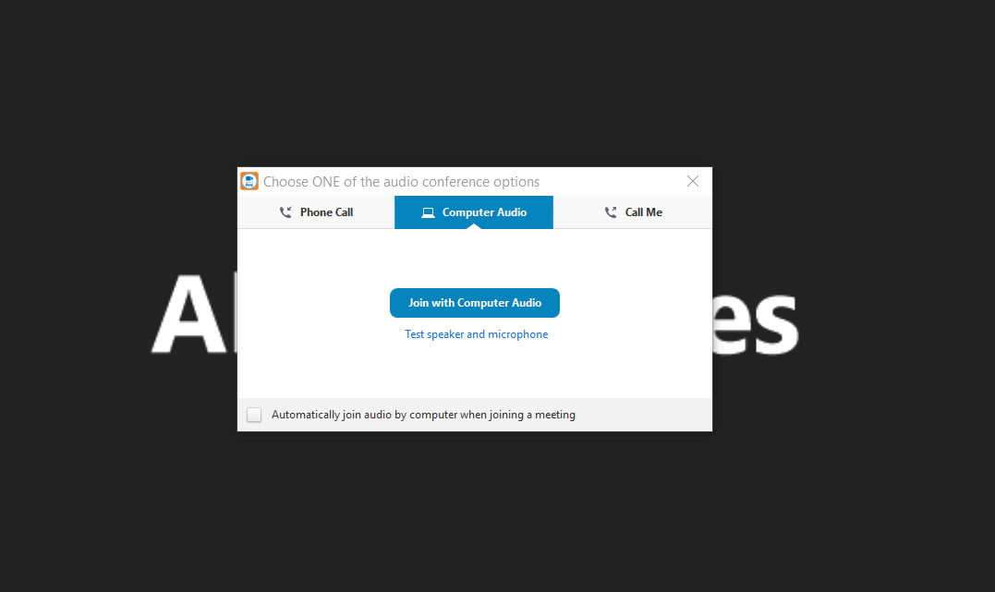
Click on the “Start Video” camera button with the red line through it (follow the yellow arrow) and your webcam will turn on, and everyone will be able to see you. You may need to move the cursor down on the page for the menu bar to appear.
This menu bar also displays the mute button (follow the blue arrow). Click to mute and unmute yourself. Background noise picks up easily. Mute yourself at all times when you’re not speaking.
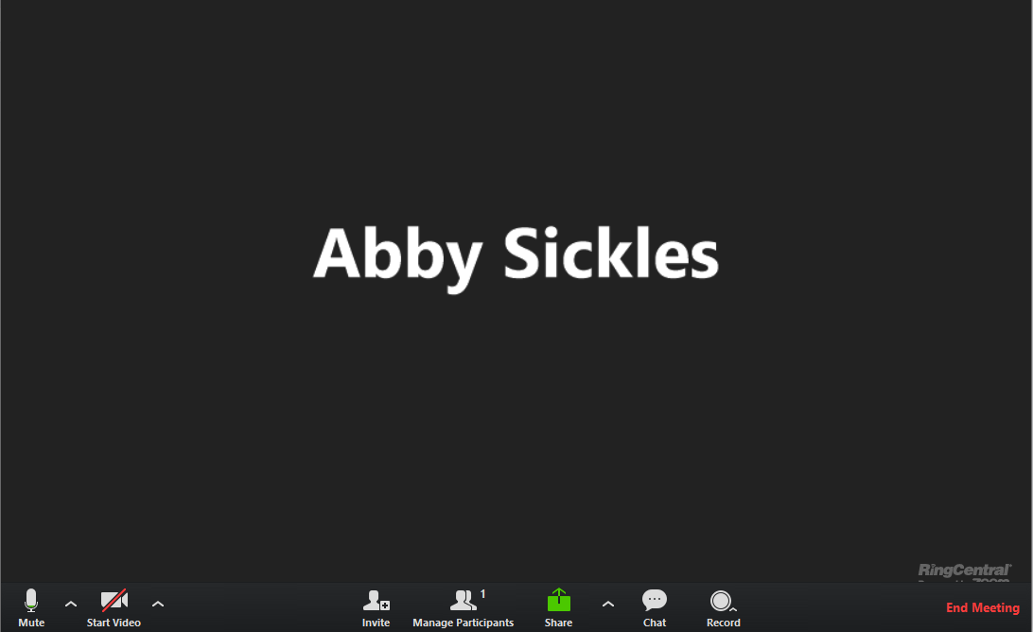
Instructions to Join via Smartphone or Tablet
Ahead of time, download the RingCentral Meetings app (free).

When it’s time for the meeting, open the app, click “Join a Meeting”, enter the Meeting ID and click “Join”. You do not need to sign in or create an account to join the meeting. Type your first and last name so others know who you are.
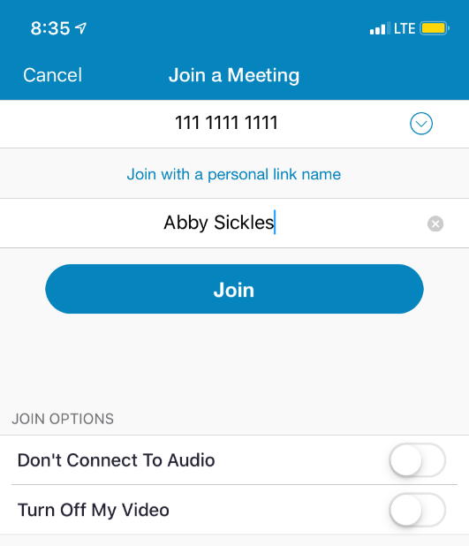
Once you’re in the meeting, you can choose how you’d like to connect to audio. Your mute and start video buttons will be on the bottom toolbar.
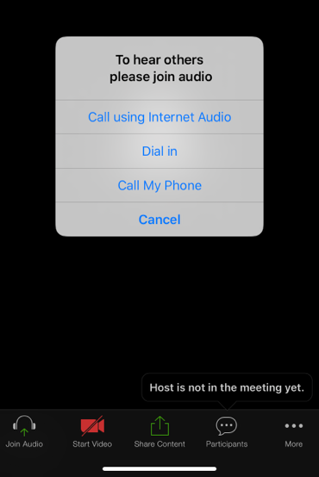

Here are some ground rules for the meeting:
- Mute yourself when you're not talking.
- Begin comments by stating your name.
- One person may speak at a time.
- Make comments or questions brief.

Our meeting will start with announcements, PHA information, the confidentiality statement and a moment of silence for those we’ve lost to PH. I will call on each person by name for brief introductions and then we will move onto the meeting topic.
I am looking forward to getting in touch with you all. Please RSVP so I know how many will be on the call.
Hope to see you there!

