About PHA

Meeting Objectives

By the end of this meeting, attendees should be able to:
- Understand what transplant is and why it is considered for some PH patients.
- More clearly and accurately picture the transplant process from the patient perspective.
- Understand when and how to discuss transplant with their provider.

Why is a meeting on Transplant important?
Lung or heart-lung transplant is a treatment option reserved for patients who are not improving on medical therapies. While transplantation can prolong survival, improve quality of life and offer a potential cure for pulmonary hypertension (PH), it also carries risk of significant complications and many factors need to be considered before going forward. Group members deserve opportunities to learn accurate information about transplant to inform their own health decisions and to ask questions of other members and medical experts. Holding meetings about transplant is an important way to reduce fear and stigma and spread accurate information about this important medical operation.
Speaker Options

- Medical professionals at PH Care Centers (PHCC) accredited by PHA. Every PHCC must offer transplant or have a referral process, so they would have knowledgeable staff to speak at meetings. Ask PHA to help you identify speakers from PHCCs by emailing Support@PHAssociation.org. If you know your closest PHCC and have a relationship with the staff, feel free to contact them directly to request a speaker. Doctors, nurse practitioners, nurses and other staff would all be able to speak on this topic.
- Transplant recipients. Patients who have had transplants can offer their perspective and tips for others, and provide support and encouragement.
- Videos from the PHA website. In virtual meetings, use the share screen function to play short videos from PHA about transplant. The best video on this topics is https://phassociation.org/classroom/about-ph/tell-me-more-about-lung-transplantation-what-is-it-all-about-and-what-is-involved/. Contact Support@PHAssociation.org for instructions on sharing videos during meetings.

Questions for the Group

- (If there is a speaker) What questions do you have for our speaker?
- Was there anything in the presentation you did not understand or would like to go over again?
- Has anyone in the group had a transplant and would like to share their experience?
- Is anyone in the group being considered for transplant? Is there anything about that you would like to share, or questions you have for the speaker or other group members?

Resources

- Refer all attendees to PHA’s transplant web page: www.PHAssociation.org/Transplant.
Support

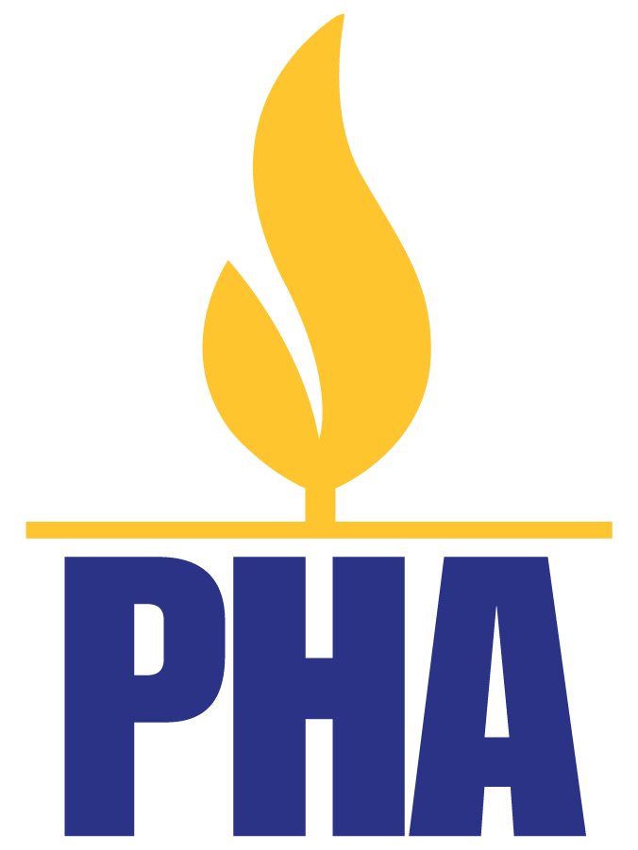
- Transplant recipients are welcome to utilize any PHA support program. They are welcome in support groups, Facebook groups and elsewhere. Find support opportunities that are right for them at www.PHAssociation.org/Support.
- Transplant recipients are also highly encouraged to volunteer with PHA. PHA needs support group leaders, fundraisers, legislative advocates and other volunteers to keep advancing the mission. Transplant recipients are still members of the community; their voices matter and their help is needed. www.PHAssociation.org/Volunteer.
- Those considering transplant are encouraged to continue attending support group meetings and can find other support opportunities at www.PHAssociation.org/Support.

